**SQL ASSESSMENT**

SQL DATABASE

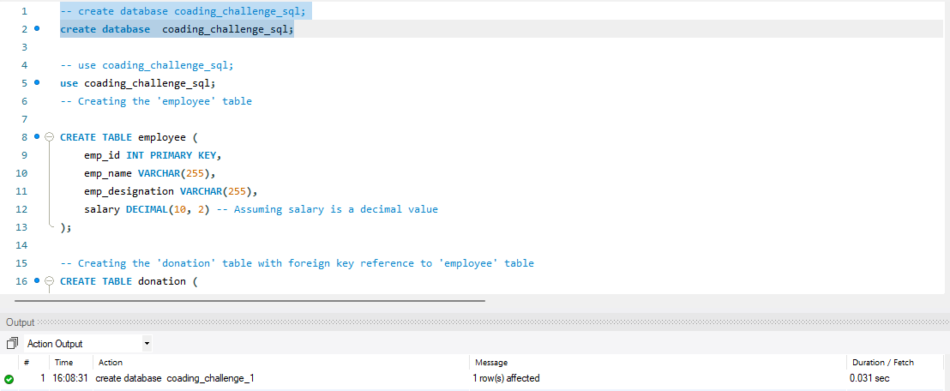

SQL TABLES

EMPLOYEE

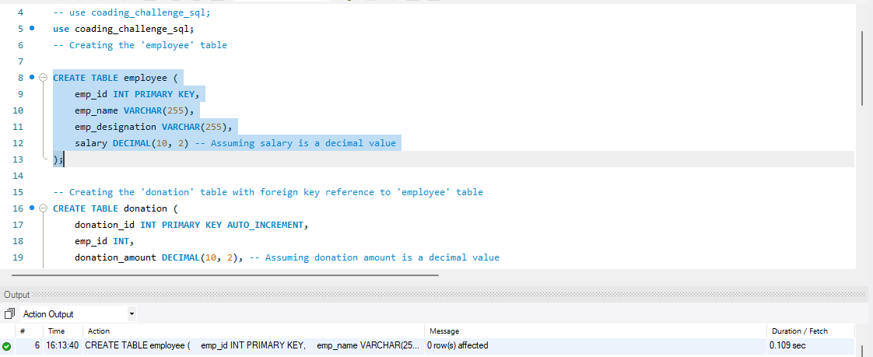

DONATION

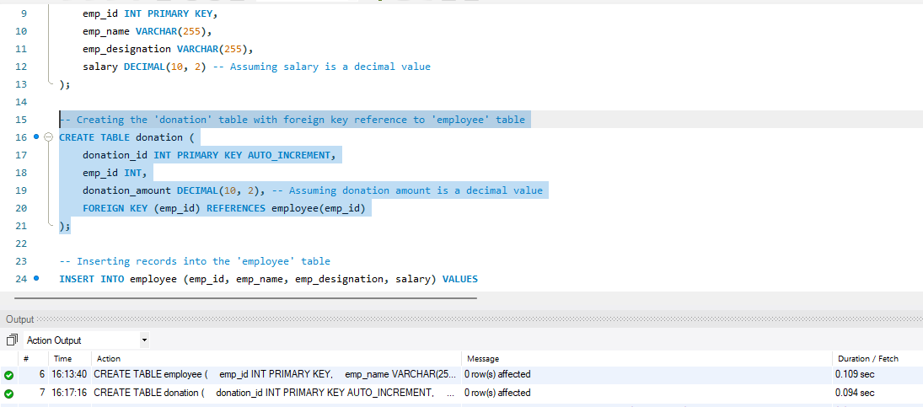

INSERT VALUES

EMPLOYEE

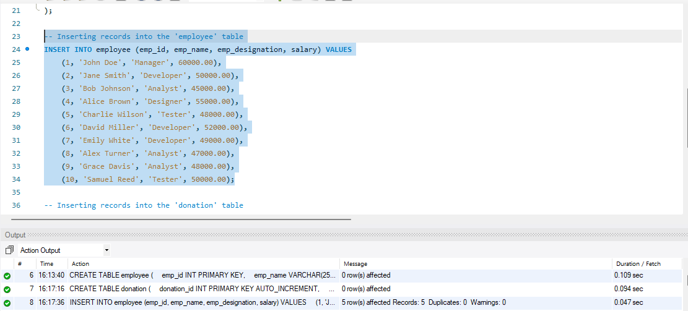

DONATION

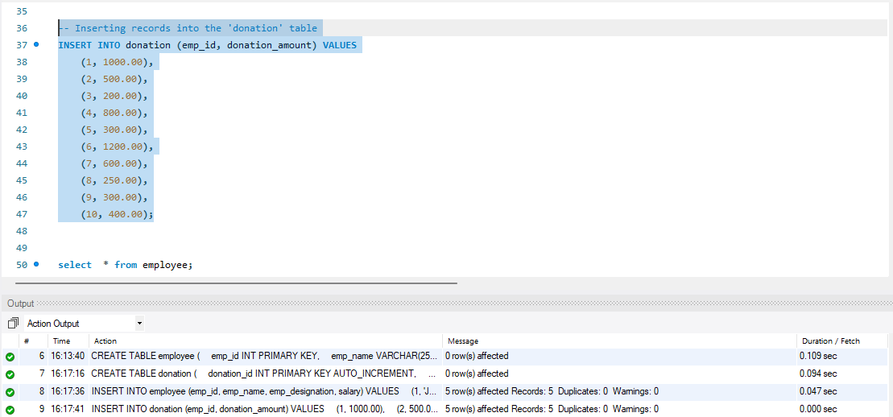

**Que 1) Execute OVER and PARTITION BY Clause in SQL Queries**

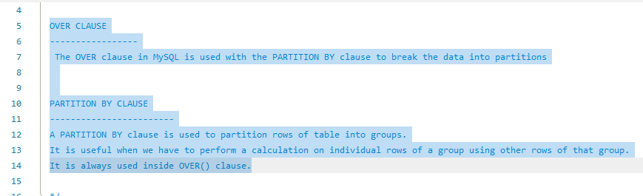

OVER CLAUSE

The OVER clause in MySQL is used with the PARTITION BY clause to break the data into partitions

PARTITION BY CLAUSE

A PARTITION BY clause is used to partition rows of table into groups.

It is useful when we have to perform a calculation on individual rows of a group using other rows of that group.

It is always used inside the OVER() clause.

USING AGGREGATE FUNCTIONS

MAX()

Return MAXIMUM salary of Employee for each Designation

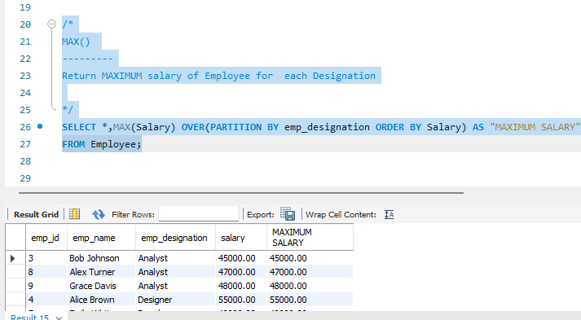

MIN()

Return MINIMUM salary of Employee for each Designation

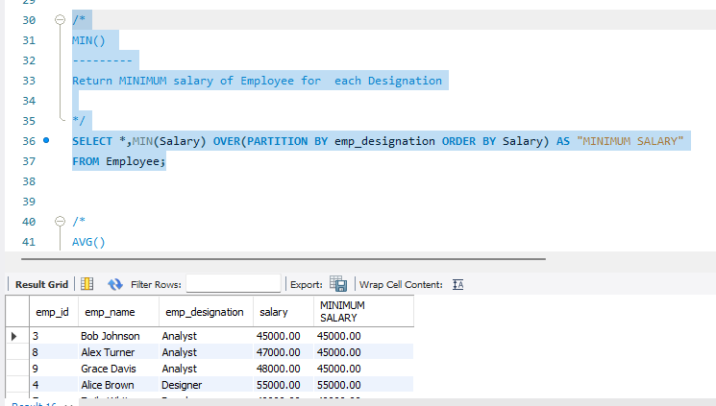

AVG()

Return AVERAGE salary of Employee for each Designation

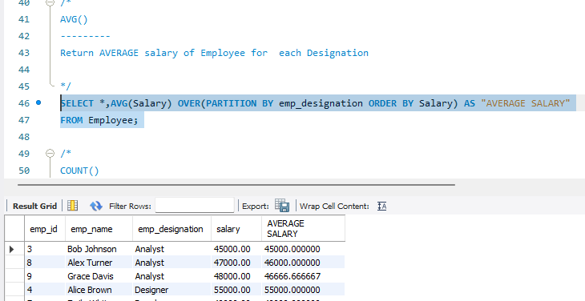

COUNT()

Return COUNT OF salary of Employee for each Designation

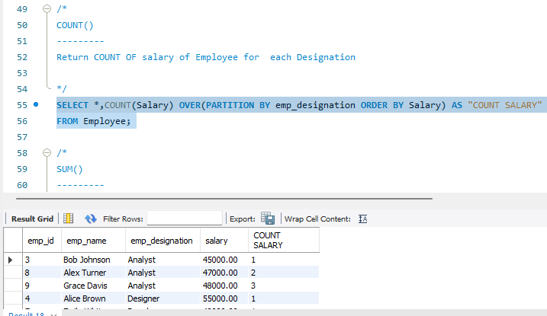

SUM()

Return SUM OF salary of Employee for each Designation

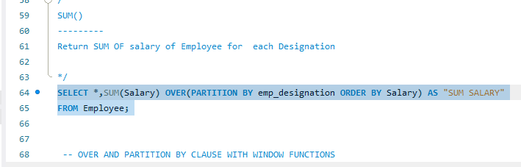

USING WINDOW FUNCTIONS

ROW_NUMBER()

The ROW_NUMBER() function in MySQL is used to returns the sequential number for each row within its partition

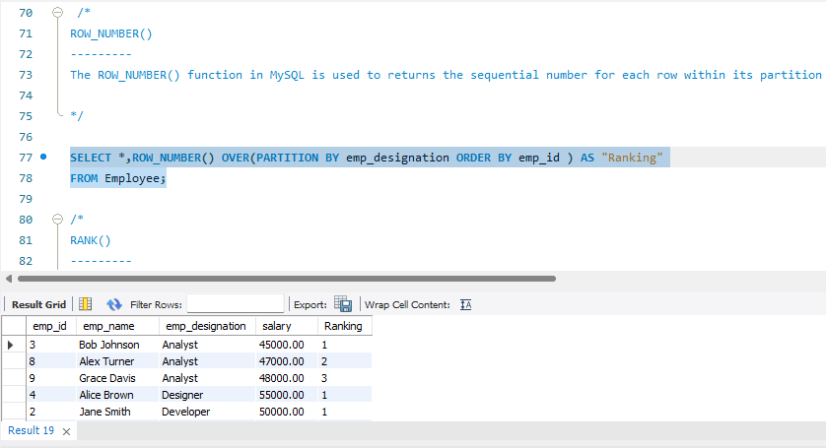

RANK()

This function will assign rank to each row within a partition with gaps.

Here, ranks are assigned in a non-consecutive manner i.e if there is a tie between values then they will be assigned same rank,

and next rank value will be previous rank + no of duplicates.

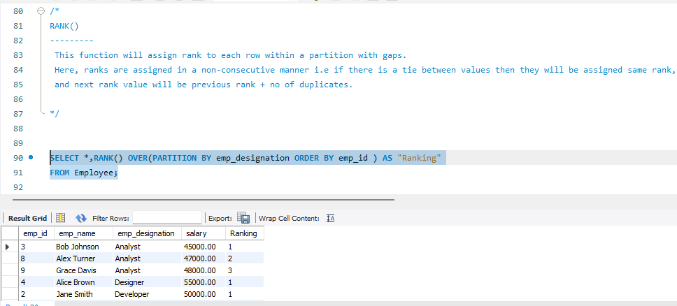

DENSE_RANK()

This function will assign rank to each row within a partition without gaps. Basically,

the ranks are assigned in a consecutive manner i.e if there is a tie between values then they will be assigned the same rank,

and next rank value will be one greater than the previous rank assigned.

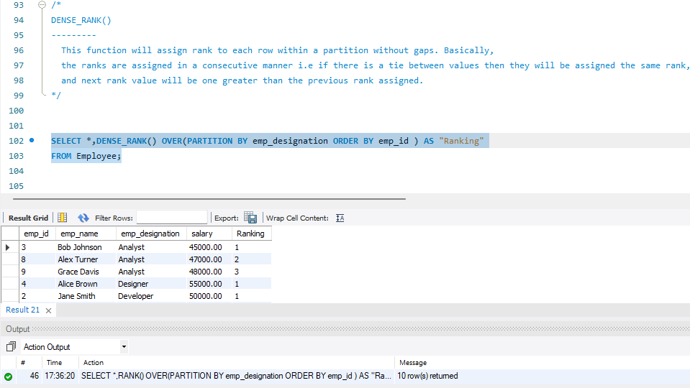

NTILE()

NTILE() function in SQL Server is a window function that distributes rows of an ordered partition

into a pre-defined number of roughly equal groups.

It assigns each group a number_expression ranging from 1

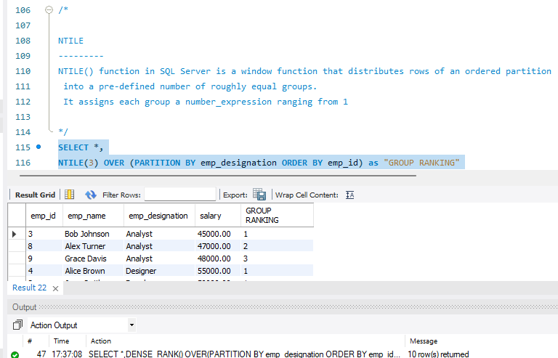

**Que 2 ) Creating subtotals and total aggregation using SQL queries**

CREATING SUBTOTAL

ROLLUP()

The ROLLUP in MySQL is a modifier used to produce the summary output,

including extra rows that represent super-aggregate summary operations.

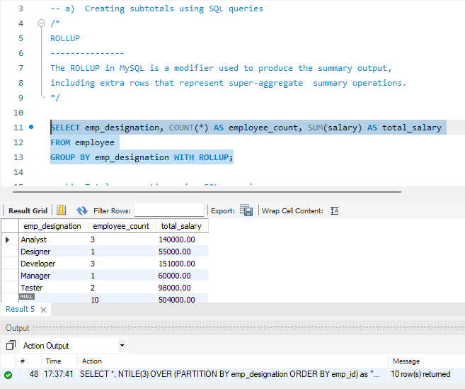

CREATING TOTAL AGGREGATION

COUNT(*)

Counts the number of rows in the result set.

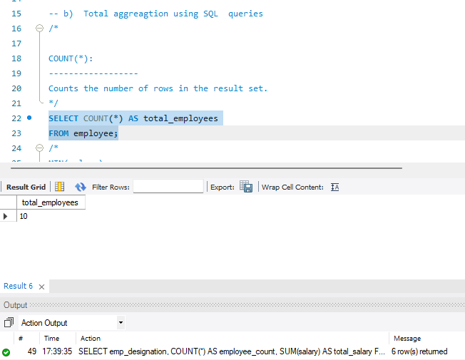

MIN()

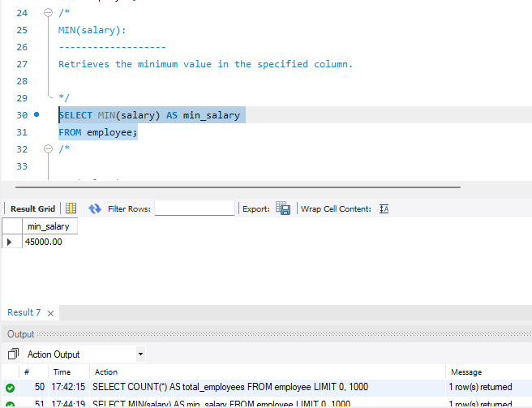

MAX()

Retrieves the MAXIMUM value in the specified column.

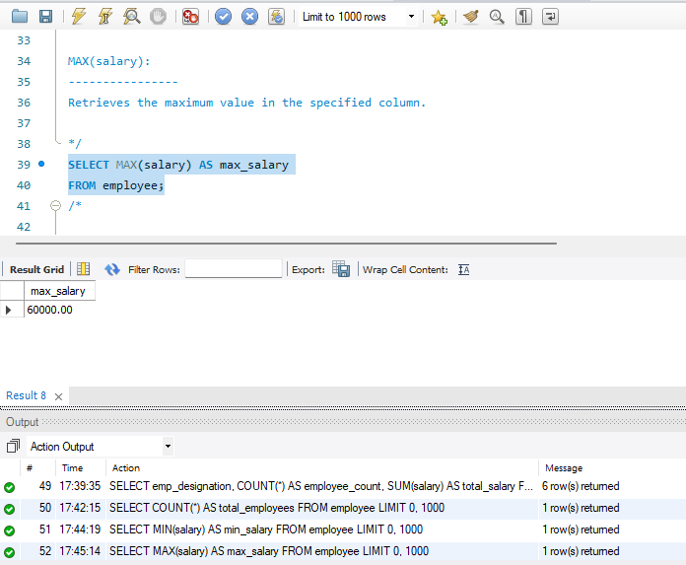

AVG()

Calculates the average value of the specified column.

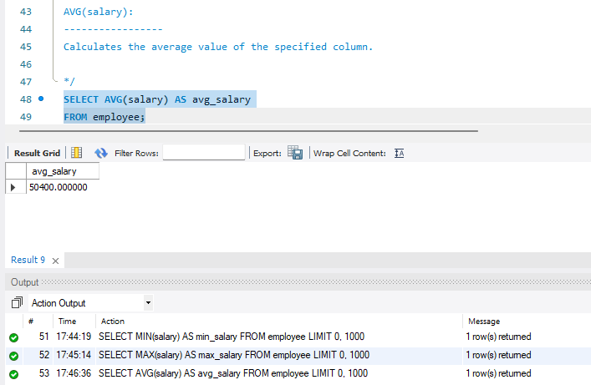

SUM()

Adds up all the values in the specified column

